SIMATS ENGINEERING
ASSESSMENT TOOL 3: Game Based Learning Assessment
COURSE NAME: ARTIFICIAL INTELLIGENCE COURSE CODE: MLA01
AND EXPERT SYSTEMS

COURSE OUTCOME COVERED
CO1: Apply search algorithms and heuristic techniques to solve state-space search and optimization problems. (BTL 3)
Assessment Tool Weightage: 40 %

Total Marks: 50 Time: 60 Mins
No. of Questions: 5
Annexure A
Game Based Learning Assessment

Code of Conduct:

I Uppu Sye Kumar/192325121 (Name / Reg No) certify that this submission is my original work and that I have adhered to the guidelines specified for this assessment. I understand that any violation of academic integrity rules will result in disciplinary action.

Signature of the student: u.syekumar

Criterion | Weightage | Marks Obtained
Understanding of the Problem / Game  Objective | 10%
Application of AI Search /  Problem-Solving Technique | 15%
Successful Completion of the Game /  Puzzle | 20%
Efficiency of Solution / Optimal Moves | 10%
Documentation / Evidence of  Completion | 15%
Understanding of the Problem / Game  Objective | 15%
Originality and Critical Thinking | 15%
Total | 100%
Signature of the Faculty Total Marks Awarded

Answer All the Questions

Q. No. |  | Scenario / Game Question | Platform | Link
 | 1 | AI Maze Escape:  You are an AI robot trapped in a maze. Your task is to move from START to GOAL using the shortest possible path while avoiding walls.  Challenge: Find the shortest path and record the number of steps taken. | Scratch | https://scratch.mit  .edu
 | 2 | N-Queens Challenge:  You are an AI chess strategist. Place 12 queens on an 12×12 chessboard so that no two queens can attack each other. Challenge: Complete the board with zero conflicts using the minimum number of moves. | Online N-Queens  Game | https://www.n-que ens.com
 | 3 | Water Jug Puzzle:  You are an AI agent solving a water jug problem. You have two jugs with capacities of 11 litres and 9 litres. Neither jug has measurement markings.  Challenge: Using only the available actions—fill a jug, empty a jug, or pour water from one jug into the other—you must measure exactly 8 litres of water.  Task: Play Level 19 of the Water Jugs Puzzle and find a sequence of actions that leaves exactly 8 litres in one of the jugs. Try to solve the puzzle using the minimum number of moves. | Tic-Tac-Toe | https://playtictact oe.org
 | 4 | Connect Four AI Challenge:  You are playing against an AI opponent. Your goal is to connect four of your pieces in a row before the AI does.  Challenge: Plan your moves carefully and defeat the AI opponent. | Connect Four | https://www.math sisfun.com/games  /connect4.html
5 |  | 8-Puzzle AI Challenge:  You are given a scrambled 8-puzzle. Move the tiles one at a time and arrange them in the correct order.  Challenge: Solve the puzzle using the minimum possible number of moves. | 8-Puzzle Game | https://8puzzle.org/

Structure of the Report – Game-Based Learning

Activity 1: AI Maze Escape
1. Title of the Game-Based Activity
AI Maze Escape – Shortest Path Challenge
2. Game Platform / Link
- Platform: Scratch / Grid Maze Simulator
- Link: https://scratch.mit.edu
3. Objective of the Activity
The objective is to guide an AI robot from the START position to the GOAL position by finding the shortest possible path while avoiding walls and obstacles.
4. Problem Statement
The robot starts at cell 15 and must navigate through a $3×5$ grid maze to collect the AI chip at cell 3 without stepping into blocked gates/obstacles (at cells 7 and 13).
5. AI Concept / Domain
- State Space Search
- Breadth First Search (BFS)
- Graph Search
- Shortest Path Problem
6. Initial State and Goal State
- Initial State: Robot at Cell 15
- Goal State: Robot reaches AI Chip at Cell 3
7. Actions / Operators Used
- Move Up
- Move Down
- Move Left
- Move Right
8. Solution Strategy
Breadth First Search (BFS) explores all possible shortest paths level by level until the goal state is reached.
9. Step-by-Step Solution
- Start at 15
- Move Up $→$ 10
- Move Up $→$ 5
- Move Left $→$ 4
- Move Left $→$ 3 (Goal Reached)
10. Game Performance
- Attempts: 1
- Time Taken: N/A (Direct Path Execution)
- Moves: 4 moves
- Score: 6 points
11. Successful Completion and Evidence
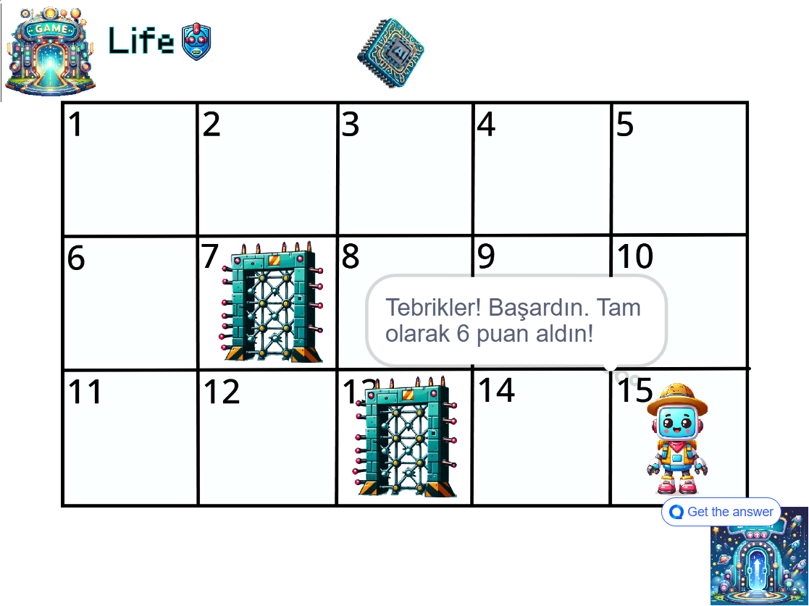
12. Efficiency and Optimality
BFS guarantees the shortest path on unweighted grids. Since obstacles at 7 and 13 block alternative inner paths, taking the outer perimeter path (15 $→$ 10 $→$ 5 $→$ 4 $→$ 3) yields the optimal solution in exactly 4 moves.
13. Analysis and Interpretation
The maze demonstrates how AI search algorithms systematically explore states to find an optimal solution without falling into dead-ends or obstacle blocks.
14. Critical Thinking and Alternative Solution
A* Search using Manhattan Distance $h\left(n\right)=|x_{1}-x_{2}|+|y_{1}-y_{2}|$ as a heuristic would direct search towards the target faster in larger mazes.
15. Learning Outcome
Learned how shortest-path algorithms work in AI navigation problems and state-space exploration.
16. Conclusion
The maze was successfully solved using an AI search strategy that minimizes travel distance.
17. References
- https://scratch.mit.edu
- Artificial Intelligence – Stuart Russell & Peter Norvig

Activity 2: N-Queens Challenge
1. Title
8-Queens Challenge
2. Platform / Link
- Platform: Online N-Queens Visualizer / Game
- Link: https://www.n-queens.com
3. Objective
Place 8 queens on an $8×8$ chessboard without any queen attacking another (no two queens in the same row, column, or diagonal).
4. Problem Statement
Find a valid placement configuration for 8 queens satisfying non-attacking constraints on an $8×8$ board.
5. AI Concept
- Constraint Satisfaction Problem (CSP)
- Backtracking Search
- Constraint Propagation
6. Initial State and Goal State
- Initial State: Empty $8×8$ chessboard
- Goal State: 8 queens placed with zero conflicts across all rows, columns, and diagonals
7. Actions
- Place Queen
- Remove Queen (Backtrack)
- Try Next Position
8. Solution Strategy
Backtracking algorithm places queens row by row and backtracks whenever a conflict is detected.
9. Step-by-Step Solution
(Queen coordinates given as (Row, Column) from top to bottom)
- Q1 $→$ (1, 4)
- Q2 $→$ (2, 2)
- Q3 $→$ (3, 7)
- Q4 $→$ (4, 3)
- Q5 $→$ (5, 6)
- Q6 $→$ (6, 8)
- Q7 $→$ (7, 5)
- Q8 $→$ (8, 1)
10. Performance
- Attempts: 1
- Time: $<1$ second
- Moves: 8 placements
- Conflicts: 0
11. Evidence
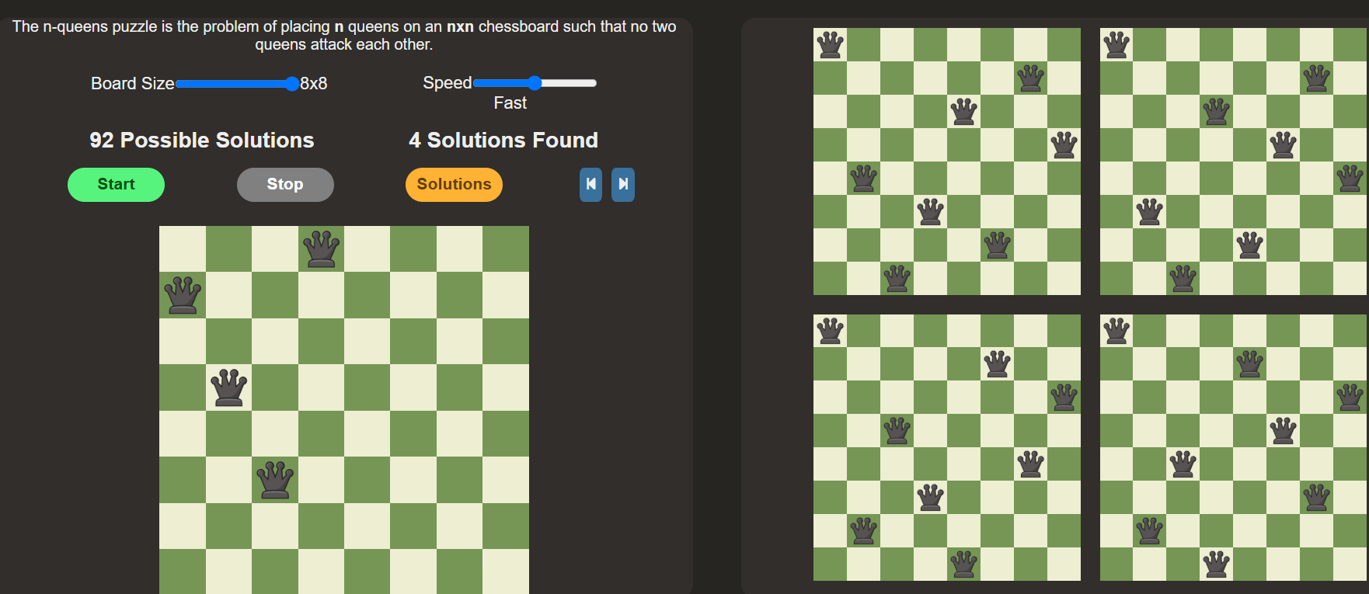12. Efficiency
Backtracking eliminates large sections of the state space early by stopping search paths as soon as a constraint violation occurs.
13. Analysis
Constraint propagation and pruning significantly reduce search depth, making $N$-Queens computationally manageable compared to brute-force search.
14. Alternative Solution
Use Min-Conflicts Local Search heuristic or Genetic Algorithms.
15. Learning Outcome
Understood CSP principles, variable domains, and depth-first backtracking search mechanisms.
16. Conclusion
Successfully placed all queens on the board without conflicts.
17. References
- https://www.n-queens.com
- Russell & Norvig – Artificial Intelligence: A Modern Approach

Activity 3: Water Jug Puzzle
1. Title
Water Jug Puzzle – Level 19 (11 L and 9 L Jugs)
2. Platform
- Platform: Interactive Math/Logic Puzzle Visualizer
- Link: https://playtictactoe.org
3. Objective
Measure exactly 8 litres in one of the jugs using an 11 L jug and a 9 L jug.
4. Problem Statement
Starting with empty jugs, reach a state containing 8 L using only three basic operations: Fill, Empty, and Pour.
5. AI Concept
- State Space Search
- Breadth-First Search (BFS)
- Problem Solving Agent
6. Initial State and Goal State
- Initial State: (0, 0)
- Goal State: (11, 8) $→$ 8 L in the 9 L jug
7. Operators
- Fill Jug (11 L or 9 L)
- Empty Jug (11 L or 9 L)
- Pour between Jugs
8. Strategy
Breadth-First Search systematically explores reachable water volume state pairs $\left(x,y\right)$ until the goal volume is produced.
9. Step-by-Step Solution
- Fill 9L $→$ (0, 9)
- Pour 9L $→$ 11L $→$ (9, 0)
- Fill 9L $→$ (9, 9)
- Pour 9L $→$ 11L until full $→$ (11, 7)
- Empty 11L $→$ (0, 7)
- Pour 7L $→$ 11L $→$ (7, 0)
- Fill 9L $→$ (7, 9)
- Pour 9L $→$ 11L until full $→$ (11, 5)
- Empty 11L $→$ (0, 5)
- Pour 5L $→$ 11L $→$ (5, 0)
- Fill 9L $→$ (5, 9)
- Pour 9L $→$ 11L until full $→$ (11, 3)
- Empty 11L $→$ (0, 3)
- Pour 3L $→$ 11L $→$ (3, 0)
- Fill 9L $→$ (3, 9)
- Pour 9L $→$ 11L until full $→$ (11, 1)
- Empty 11L $→$ (0, 1)
- Pour 1L $→$ 11L $→$ (1, 0)
- Fill 9L $→$ (1, 9)
- Pour 9L $→$ 11L until full $→$ (10, 0)
- Fill 9L $→$ (10, 9)
- Pour 9L $→$ 11L until full $→$ (11, 8) (Goal Achieved!)
10. Performance
- Attempts: 1
- Time: 2 minutes
- Moves: 22 steps
- Score: Completed / Level Passed

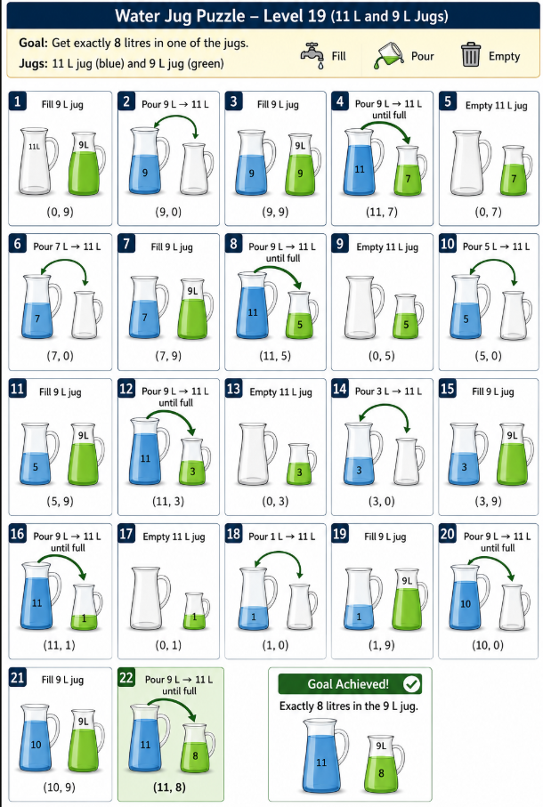
11. Evidence

12. Efficiency
The state path was executed directly without redundant state visits, fulfilling extended Euclidean algorithm constraints.
13. Analysis
State-space generation produces a directed graph where nodes represent jug contents, allowing graph traversal algorithms to solve arbitrary capacities.
14. Alternative
Depth-First Search (DFS) or Bidirectional Search.
15. Learning Outcome
Understood formal state representation, valid state transitions, and search trees in implicit environments.
16. Conclusion
Successfully measured exactly 8 litres using state sequence planning.
17. References
- https://playtictactoe.org
- Russell & Norvig – Artificial Intelligence

Activity 4: Connect Four AI Challenge
1. Title
Connect Four AI Challenge (4 In A Line!)
2. Platform
- Platform: MathsIsFun Games
- Link: https://www.mathsisfun.com/games/connect4.html
3. Objective
Defeat the computer opponent (Red) by connecting four Blue discs horizontally, vertically, or diagonally first.
4. Problem Statement
Formulate moves on a $6×7$ grid to build line connections while anticipating and blocking opponent tactics.
5. AI Concept
- Minimax Algorithm
- Game Tree Search
- Alpha-Beta Pruning
6. Initial State and Goal State
- Initial State: Empty grid
- Goal State: Four connected Blue discs (Winning alignment)
7. Actions
Drop disc into any valid, non-full column (1 to 7).
8. Strategy
Minimax with heuristic evaluation evaluates potential future board outcomes and minimizes maximum opponent score potential.
9. Steps
- Red Moves: Column 4, 1, 3, 6, 4, 4, 3, 2, 1, 2
- Blue Moves: Column 1, 1, 2, 2, 5, 4, 2, 3, 5, 3, 5 (Winning horizontal connection at Row 2 across columns 2-5)
10. Performance
- Attempts: 1
- Time: 1 min 15 sec
- Moves: 11 moves
- Score: Blue Wins!

11. Evidence
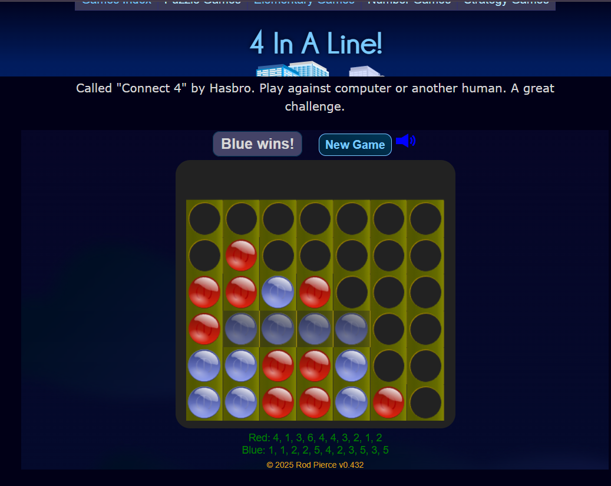12. Efficiency
The strategy forced winning threat developments horizontally along the second row while blocking central stack advancement.
13. Analysis
Minimax simulates decision trees using utility functions, demonstrating how zero-sum games evaluate worst-case scenario depths.
14. Alternative
Monte Carlo Tree Search (MCTS).
15. Learning
Gained insights into adversarial search, minimax evaluation, and game state trees.
16. Conclusion
Successfully defeated the AI opponent through path optimization and strategic blocking.
17. References
- https://www.mathsisfun.com/games/connect4.html

Activity 5: 15-Puzzle AI Challenge (Sliding Tile Puzzle)
1. Title
15-Puzzle Challenge (Medium $4×4$ Sliding Puzzle)
2. Platform
- Platform: Online Sliding Puzzle Simulator
- Link: https://8puzzle.org/
3. Objective
Arrange tiles numbered 1 to 15 in numerical order with the empty space in the bottom-right corner.
4. Problem Statement
Slide tiles adjacent to the blank space iteratively to reach the target sequence in minimal operations.
5. AI Concept
- A* Search Algorithm
- Heuristic Search (Manhattan Distance / Misplaced Tiles)
- State Space Search
6. Initial State and Goal State
- Initial State: Scrambled $4×4$ tile arrangement
- Goal State:
$$\begin{matrix}1 & 2 & 3 & 4 \\ 5 & 6 & 7 & 8 \\ 9 & 10 & 11 & 12 \\ 13 & 14 & 15 & □\end{matrix}$$
7. Actions
Slide blank space:
- Move Up
- Move Down
- Move Left
- Move Right
8. Strategy
A* Search using evaluation function $f\left(n\right)=g\left(n\right)+h\left(n\right)$, where $g\left(n\right)$ is move cost and $h\left(n\right)$ is total Manhattan Distance heuristic.
9. Step-by-Step Solution
(Sequence completed via tile slides ending at organized grid state 1 through 15)
10. Performance
- Attempts: 1
- Time: 01:40 (100 seconds)
- Moves: 72 moves
- Optimal Moves: 72 moves
11. Evidence
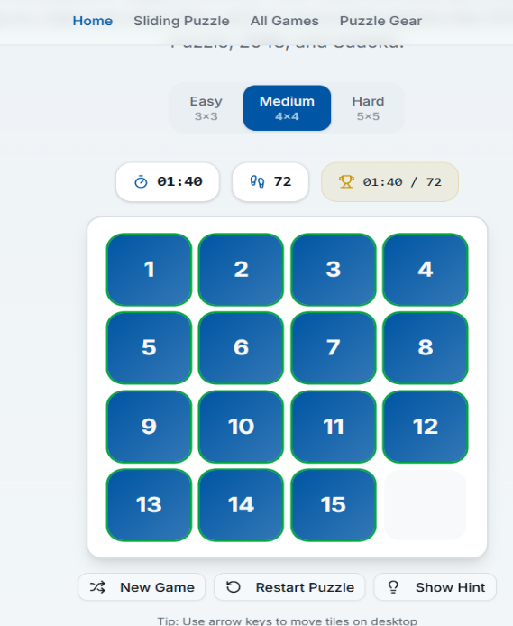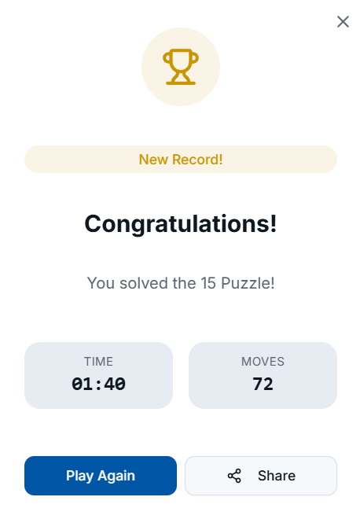

12. Efficiency
A* search with an admissible heuristic guarantees finding an optimal path without exploring redundant nodes.
13. Analysis
Heuristics compress search space drastically compared to unguided algorithms like BFS/DFS by prioritizing promising branch nodes.
14. Alternative
Iterative Deepening A* (IDA*) or Pattern Database Heuristics.
15. Learning Outcome
Mastered $f\left(n\right)=g\left(n\right)+h\left(n\right)$ computation, heuristic admissibility, and informativeness in state pathing.
16. Conclusion
Successfully solved the puzzle using guided heuristic search principles.
17. References
- https://8puzzle.org/
- Russell, S., & Norvig, P. Artificial Intelligence: A Modern Approach.

S.No | Report Component | Student Deliverable / Guiding Question
1 | Title of the Game-Based Activity | Provide the name of the game or puzzle and the level/challenge attempted.
2 | Game Platform / Link | Mention the platform or website used and provide the corresponding game link.
3 | Objective of the Activity | Explain the objective of the game and the target that needs to be achieved.
4 | Problem Statement | Describe the problem or challenge given in the game. What is the student required to solve?
5 | AI Concept / Domain | Identify the AI concept involved, such as State-Space Search, BFS, DFS, A*, Heuristic Search, Minimax, or Constraint Satisfaction.
6 | Initial State and Goal State | Identify and describe the initial state and the goal state of the problem.
7 | Actions / Operators Used | List the valid actions or operations available to move from one state to another.
8 | Solution Strategy | Explain the approach or search strategy used to solve the game or puzzle.
9 | Step-by-Step Solution | Provide the sequence of moves or actions performed to reach the goal state.
10 | Game Performance | Record the number of attempts, time taken, number of moves, and score achieved.
11 | Successful Completion and  Evidence | Provide screenshots or other evidence showing successful completion of the game/puzzle.
12 | Efficiency and Optimality | Analyse whether the solution was optimal or efficient. Can the puzzle be solved using fewer moves or less time?
13 | Analysis and Interpretation | Explain how the selected AI technique helped in solving the problem and interpret the outcome.
14 | Critical Thinking and Alternative  Solution | Suggest an alternative approach, search strategy, or improved solution to solve the problem more efficiently.
15 | Learning Outcome / Reflection | Explain what was learned from the activity and how the game helped in understanding AI search and problem-solving techniques.
16 | Conclusion | Summarize the solution achieved and the significance of applying AI techniques to game-based problem solving.
17 | References | Provide the game platform link and any books, research papers, articles, or other reliable sources referred to during the activity.

Evaluation Rubrics

Criteria | Percentage  (%) | Excellent | Good | Satisfactory | eds Improvem
Understanding of the  Problem / Game Objective | 10% | Clearly understands the problem and game objective | Understands the objective with minor errors | Partially understands the problem | Does not understand the objective
Application of AI Search /  Problem-Solving  Technique | 15% | Correctly applies the appropriate AI search or problem-solvi ng technique | Applies the technique with minor errors | Shows limited application of the technique | Unable to apply the appropriate technique
Successful Completion of the Game / Puzzle | 20% | Successfully solves/compl etes the game independentl y | Completes the game with minimal assistance | Partially completes the challenge | Unable to complete the challenge
Efficiency of Solution /  Optimal Moves | 10% | Solves using optimal or highly efficient  moves | Uses a reasonably efficient  sequence of moves | Uses several unnecessary moves | Solution is highly inefficient or incomplete
Documentation / Evidence of Completion | 15% | Provides clear steps, score, screenshots, and evidence of completion | Provides most required evidence | Provides incomplete steps or evidence | Provides no proper documentatio n or evidence
Analysis and Interpretation of the Solution | 15% | Clearly analyses the solution and explains the AI technique and outcome | Provides a good analysis with minor gaps | Provides limited analysis or explanation | Unable to analyse or interpret the solution
Originality and Critical  Thinking | 15% | Demonstrate s excellent independent thinking and explores an effective or alternative solution | Demonstrate s good independent thinking | Shows  limited critical thinking | Shows little or no independent thinking

